Market Place Project

Alex Stevens



Signed Pledge:” I pledge that this work is entirely mine, and mine alone (except code provided by my instructor”

The only people that helped me with my project are my Professor and my tutor.

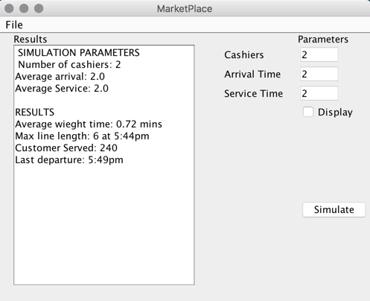

Time Card: I spent a totally of approximately 10 hours on this project.